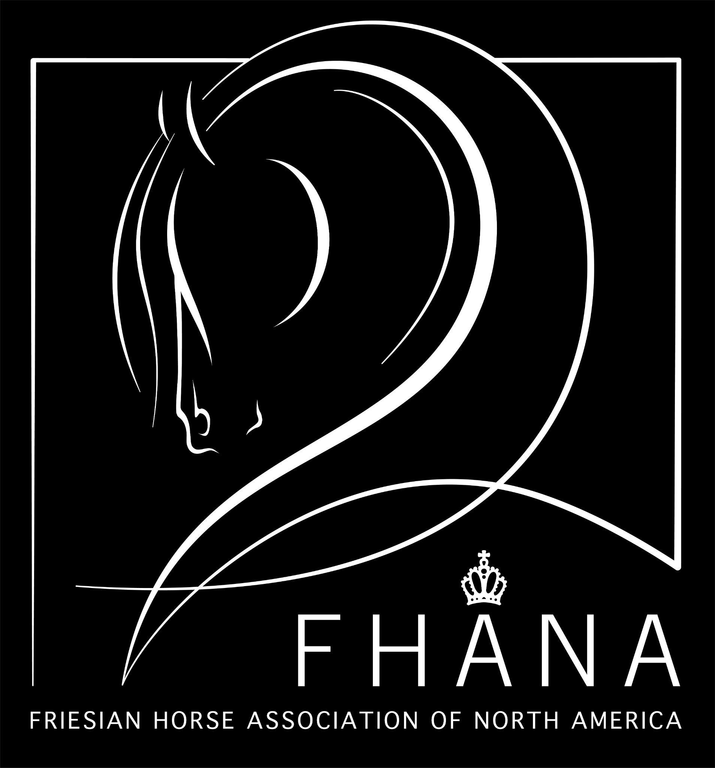

2023 FHANA Official Stallion Viewing

Judges: Pieter Bergsma & Corrie Terpstra

Stallions born 2021 (2 year)

890 Remington, EFF (202101166) Vb
DOB 03-31-2021 * Chipnr: 981020037351213
Stam: 103 Height: Inbreeding: 3.52
Sire: Mees 497 (201201049) Stb Sport-Elite AAA
Dam: Marieke van de Egberdina Hoeve (201200199) Stb Ster Sport AA
Sire of Dam: Norbert 444 (200400578) Stb Sport Preferent AAA
Breeder/Owner:Annette Carpenter, Modesto, CA

Walk | Trot | Canter | Carriage & Balance | Agility | Transitions | Impulsions | Total Score

891 Primogénito de Ponce (202104053) Vb
DOB 04-21-2021 * Chipnr: 981020045103827
Stam: 035 Height: Inbreeding: 2.54
Sire: Tjalbert 460 (200600983) Stb AA
Dam: Pamelia Z. (201301448) Stb Ster
Sire of Dam: Wybren 464 (4A6D29091A) Stb Sport AA
Breeder/Owner: Frisones Los Ponce, Sacramento, CA

Walk | Trot | Canter | Carriage & Balance | Agility | Transitions | Impulsions | Total Score

892 Rikst van 't Mulligen (202100053) Vb
DOB: 01-31-2021 * Chipnr: 528210006404152
Stam: 025 Height: Inbreeding: 1.76
Sire: Teun 505 (201400668) Stb Sport AAA
Dam: Wytske fan Sweach (201501793) Stb
Sire of Dam: Gerben 479 (201000762) Stb Sport AAA
Breeder: Flier, NL
Owner: Cosme Galaviz, South El Monte, CA

Walk | Trot | Canter | Carriage & Balance | Agility | Transitions | Impulsions | Total Score

Stallions born 2018-2020 (3-5 Year) No Ster

893 Merijn W (202002160) Vb
DOB 05-21-2020 * Chipnr: 528210006247142
Stam: 110 Height: Inbreeding: 0.98
Sire: Tiede 501 (201400450) Stb Sport AAA
Dam: Wanda Mintsje K (201502824) Stb Ster
Sire of Dam: Pier 448 (200501700) Stb Sport AA
Breeder: P.J.M. Wilms-Strijbos, NL
Owner: Avalos Refugio, Strathmore, CA

Walk | Trot | Canter | Carriage & Balance | Agility | Transitions | Impulsions | Total Score

894 Marco of Varna (202001638) Vb
DOB: 04-18-2020 * Chipnr: 981020035172939
Stam: 099 Height: Inbreeding: 0.39
Sire: Meinte 490 (201200609) Stb Sport-Elite AA
Dam: Ina vom Friesenhof Altmark (201001096) Stb Ster A
Sire of Dam: Maurus 441 (200403319) Stb Sport
Breeder: Klaas Steenbeek, Clinton, ON
Owner: Frisones Los Ponce, Sacramento, CA

Walk | Trot | Canter | Carriage & Balance | Agility | Transitions | Impulsions | Total Score

895 Myles of Smiles, EFF (202002637) Vb
DOB: 06-09-2023 * Chipnr: 981020035159931
Stam: 103 Height: Inbreeding: 0.98
Sire: Tsjalle 454 (200600248) Stb Sport-Elite Preferent AAA
Dam: Vroukje van Diphoorn (201401351) Stb
Sire of Dam: Andries 415 (200037791) Stb Sport
Breeder:Annette Carpenter, Modesto, CA
Owner: Frisones Los Ponce, Sacramento, CA

Walk | Trot | Canter | Carriage & Balance | Agility | Transitions | Impulsions | Total Score

896 Menno of Varna (202000911) Vb
DOB: 03-25-2020 * Chipnr: 981020027820900
Stam: 103 Height: Inbreeding: 1.17
Sire: Meinte 490 (201200609) Stb Sport-Elite AA
Dam: Janet P.J. (201100859) Stb Ster
Sire of Dam: Onne 376 (199619181) Stb Sport
Breeder/Owner: Frisones Los Ponce, Sacramento, CA

Walk | Trot | Canter | Carriage & Balance | Agility | Transitions | Impulsions | Total Score

898 Kjelt V (201900630) Vb
DOB: 03-21-2019 * Chipnr: 528210006017424
Stam: 070 Height: Inbreeding: 4.1
Sire: Jehannes 484 (201100004) Stb Sport-Elite AAA
Dam: Rasja V. (201301139) Stb Ster
Sire of Dam: Beart 411 (200008071) Stb Sport Preferent
Breeder: G. de Vries, NL
Owner: Victor Barajas, Hughson, CA

Walk | Trot | Canter | Carriage & Balance | Agility | Transitions | Impulsions | Total Score

Stallions born 2017-2019 (4-6) Ster

897 Lawrence, EFF (201902520) Vb Ster
DOB 05-22-2019 * Chipnr: 981020023447752
Stam: 141 Height: 160 Inbreeding: 0.78
Sire: Uldrik 457 (200601504) Stb AAA
Dam: Enette fan Henswoude (200904419) Stb Ster
Sire of Dam: Wobke 403 (199901951) Stb Sport
Breeder/Owner:Annette Carpenter, Modesto, CA

Walk | Trot | Canter | Carriage & Balance | Agility | Transitions | Impulsions | Total Score

