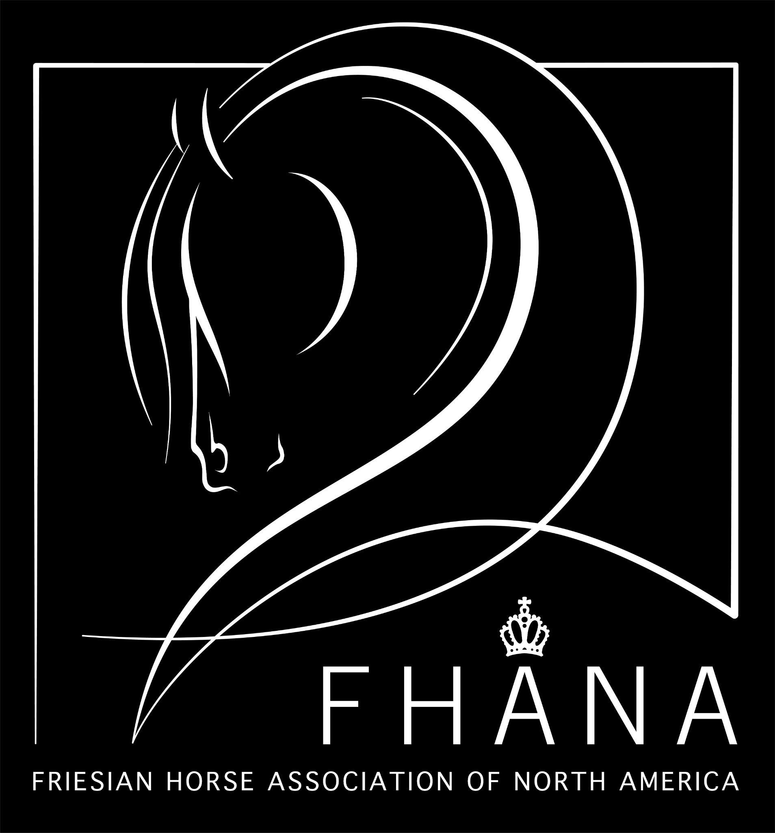

2023 FHANA Official Stallion Viewing

Judges: Pieter Bergsma & Corrie Terpstra

Stallions born 2021 (2 year)
931 Storm KCF (202102072) Vb
DOB: 04-29-2021 * Chipnr: 981020037337071
Stam: 131 Height: Inbreeding: 1.95
Sire: Julius 486 (201102814) Stb Sport-Elite AAA
Dam: Martie KCF (201202969) Stb Kroon AA
Sire of Dam: Tonjes 459 (200601244) Stb Sport AA
Breeder/Owner: KCF Farms, St. Thomas, ON

Walk | Trot | Canter | Carriage & Balance | Agility | Transitions | Impulsions | Total Score

932 Sepke van de Meerbos (202100708) Vb
DOB: 03-27-2021 * Chipnr: 528210006311502
Stam: 050 Height: Inbreeding: 3.13
Sire: Tiede 501 (201400450) Stb Sport AAA
Dam: Anke fan Meren-State (201600334) Stb Ster
Sire of Dam: Bikkel 470 (200801997) Stb Sport AA
Breeder: M. Driessen, NL
Owner: Lisa Zijlstra, Clarksville, MI

Walk | Trot | Canter | Carriage & Balance | Agility | Transitions | Impulsions | Total Score

933 Piter fan North Ster (202102180) Vb
DOB: 05-14-2021 * Chipnr: 981020037342791
Stam: 187 Height: Inbreeding: 1.14
Sire: Matthys 504 (201201682) Stb Sport-Elite AAA
Dam: Wira fan North Ster (201502157) Stb Ster
Sire of Dam: Sape 381 (199732061) Stb Sport
Breeder/Owner: Lana & Megan Markey & Family, Wausau, WI

Walk | Trot | Canter | Carriage & Balance | Agility | Transitions | Impulsions | Total Score

934 Ryker fan Stal Snyder (202103546) Vb
DOB: 01-01-2021 * Chipnr: 981020037801857
Stam: 109 Height: Inbreeding: 3.71
Sire: Matthys 504 (201201682) Stb Sport-Elite AAA
Dam: Heddeke van de Demro stables (201000251) Stb Ster Sport AA
Sire of Dam: Jorn 430 (200300438) Stb Sport-Elite AA
Breeder/Owner: Katherine A Hammond & Snyder Performance Horses, St. Paris, OH

Walk | Trot | Canter | Carriage & Balance | Agility | Transitions | Impulsions | Total Score

935 Romeo MFF (202102244) Vb
DOB: 05-09-2021 * Chipnr: 981020037354303
Stam: 050 Height: Inbreeding: 1.95
Sire: Julius 486 (201102814) Stb Sport-Elite AAA
Dam: Ivanka Nicole (201004014) Stb Kroon Sport AA
Sire of Dam: Sipke 450 (200501382) Stb Sport AA
Breeder/Owner: Erin Miley, Miley Friesians, Greenville, OH

Walk | Trot | Canter | Carriage & Balance | Agility | Transitions | Impulsions | Total Score

946 Solair (202104073) Vb
DOB: 02-19-2021 * Chipnr: 981020045086266
Stam: 078 Height: Inbreeding: .98
Sire: Julius 486 (201102814) Stb Sport-Elite AAA
Dam: Luna Prada (201104729) BBII VB
Sire of Dam: Versachi (200605282) Vb
Breeder: Lavon Jess, Arthur, IL
Owner: Philip Farmwald, Sullivan, IL

Walk | Trot | Canter | Carriage & Balance | Agility | Transitions | Impulsions | Total Score

Stallions born 2018-2020 (3-5 Year) No Ster
936 Murk fan North Ster (202003374) Vb
DOB: 05-29-2020 * Chipnr: 981020035159953
Stam: 187 Height: Inbreeding: 0.78
Sire: Hessel 480 (201000839) Stb Sport AA
Dam: Lotje fan North Ster (201103424) Stb Ster
Sire of Dam: Sipke 450 (200501382) Stb Sport AA
Breeder/Owner: Lana & Megan Markey & Family, Wausau, WI

Walk | Trot | Canter | Carriage & Balance | Agility | Transitions | Impulsions | Total Score

937 Oltman of Swan Lake (202001873) Vb
DOB: 05-02-2020 * Chipnr: 981020035188870
Stam: 065 Height: Inbreeding: 1.37
Sire: Jehannes 484 (201100004) Stb Sport-Elite AAA
Dam: Helena Wv. (201003555) Stb Ster
Sire of Dam: Meinse 439 (200401387) Stb
Breeder/Owner: Chris Piovarchy, Valley City, OH

Walk | Trot | Canter | Carriage & Balance | Agility | Transitions | Impulsions | Total Score

938 Mette fan North Ster (202003452) Vb
DOB: 05-29-2020 * Chipnr: 981020035185804
Stam: 187 Height: Inbreeding: 1.17
Sire: Matthys 504 (201201682) Stb Sport-Elite AAA
Dam: Wira fan North Ster (201502157) Stb Ster
Sire of Dam: Sape 381 (199732061) Stb Sport
Breeder/Owner: Lana & Megan Markey & Family, Wausau, WI

Walk | Trot | Canter | Carriage & Balance | Agility | Transitions | Impulsions | Total Score

939 Nikele Onyx of Swan Lake (202003533) Vb
DOB: 05-14-2020 * Chipnr: 981020035173685
Stam: 050 Height: Inbreeding: 2.15
Sire: Norbert 444 (200400578) Stb Sport Preferent AAA
Dam: Ivanka Nicole (201004014) Stb Kroon Sport AA
Sire of Dam: Sipke 450 (200501382) Stb Sport AA
Breeder: Crystal Burr, Greenville, OH
Owner: Chris Piovarchy, Valley City, OH

Walk | Trot | Canter | Carriage & Balance | Agility | Transitions | Impulsions | Total Score

940 Ouren fan North Ster (202001821) Vb
DOB: 04-28-2020 * Chipnr: 981020027050746
Stam: 187 Height: Inbreeding: 1.56
Sire:Tsjalle 454 (200600248) Stb Sport-Elite Preferent AAA
Dam: Ibeltsje fan North Ster (201003549) Stb Kroon AA
Sire of Dam: Sipke 450 (200501382) Stb Sport AA
Breeder/Owner: Lana & Megan Markey & Family, Wausau, WI

Walk | Trot | Canter | Carriage & Balance | Agility | Transitions | Impulsions | Total Score

941 Marten van de Marne (202000801) Vb
DOB: 03-29-2020 * Chipnr: 528210006060864
Stam: 103 Height: 158 Inbreeding: 2.15
Sire: Alwin 469 (200801759) Stb Sport Preferent AAA
Dam: Rommie van de Marne (200502572) Stb Kroon Preferent AA
Sire of Dam: Jasper 366 (199520431) Stb Sport-Elite Preferent
Breeder: D. van Foeken, NL
Owner: Carlow Macias, Monee, IL

Walk | Trot | Canter | Carriage & Balance | Agility | Transitions | Impulsions | Total Score

942 Kobain M.F.F. (201901936) Vb
DOB: 05-10-2019 * Chipnr: 981020023423721
Stam: 002 Height: Inbreeding: 2.54
Sire: Tjaarda 483 (200601084) Stb Sport-Elite
Dam: Tessa van de Zuiderwaard (199809630) Stb Ster A
Sire of Dam: Tamme 276 (197902761) Stb
Breeder/Owner: Erin Miley, Miley Friesians, Greenville, OH

Walk | Trot | Canter | Carriage & Balance | Agility | Transitions | Impulsions | Total Score

943 Hilbrân fan North Ster (201802960) Vb
DOB: 05-29-2018 * Chipnr: 981020023447246
Stam: 002 Height 167 Inbreeding: 0.78
Sire: Wybren 464 (200705907) Stb Sport AA
Dam: Lyren fan North Ster (201103914) Stb Model AA
Sire of Dam: Sipke 450 (200501382) Stb Sport AA
Breeder: Lana & Megan Markey & Family, Wausau, WI
Owner: Roger &/or Dana Hartle, Crossville, TN

Walk | Trot | Canter | Carriage & Balance | Agility | Transitions | Impulsions | Total Score

Stallions born 2017-2019 (4-6) Ster
944 Jeldert v.d Schans (201900723) Vb Ster
DOB: 03-28-2019 * Chipnr: 528210006070377
Stam: 102 Height: 167 Inbreeding:
Sire: Jurre 495 (201102129) Stb Sport-Elite AAA
Dam: Ljiske van Hoeve Jacolie (200300818) Stb Ster)
Sire of Dam:Tsjerk 328 (199008331) Stb Sport Preferent
Breeder: B. Katoele, NL
Owner: Joshua Perez, Manvel, TX

Walk | Trot | Canter | Carriage & Balance | Agility | Transitions | Impulsions | Total Score

945 Jasper van de Greephorst (201900388) Vb Ster
DOB: 03-19-2019 * Chipnr: 528210006034871
Stam: 145 Height: 160 Inbreeding: .59
Sire: Alwin 469 (200801759) Stb Sport Preferent AAA
Dam: Vera Fan Nico stables (201402433) Stb Ster
Sire of Dam: Pier 448 (200501700) Stb Sport AA
Breeder: Boonstra/Feer, NL
Owner: Greivin Retana, Clarksburg, MD

Walk | Trot | Canter | Carriage & Balance | Agility | Transitions | Impulsions | Total Score

