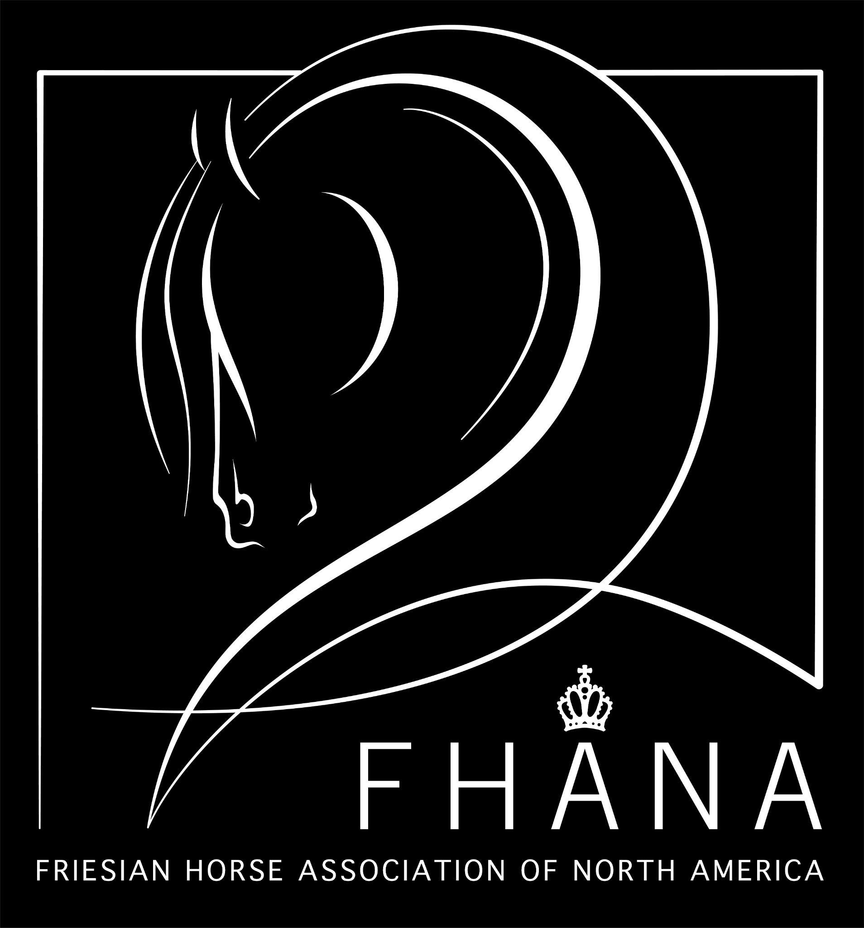

2023 FHANA Mare Show West

Judges: Wil Thijssen & Dik Brummel

Category 1: 1e Yearlings & 2 yr. Olds (Top 2 Advance)

Category 2: Ster Mares 3-4 yrs old (Top 2 Advance)

Category 3: Ster Mares 5 yrs & Older; Provisional Kroon Mares (Top 2 Advance)

1100 Nika fan Extreme Friesians (202003502) Stb Ster, Provisional Kroon
DOB: 07-08-2020 * Chipnr: 981020035172352
Sire: Tiede 501 (201400450) Stb Sport AAA
Dam: Baukje út 't Westen (200805295) Stb Kroon AA
Sire of Dam: Feike 395 (199306571) Stb Sport
Breeder/Owner: Joe & Kayla Michielli, Extreme Friesian Stable
Earned during 2023 inspection

Racial Type | Confirmation | Feet & Legs | Walk | Trot | Premie

1101 Namke fan Dunegea (202001902) Stb Ster, Provisional Kroon
DOB: 04-27-2020 * Chipnr: 981020035167010
Sire: Haike 482 (201003370) Stb Sport AA
Dam: Anneke fan d'ald Loop (200800051) Stb Ster Sport
Sire of Dam: Harmen 424 (200223361) Stb Sport
Breeder/Owner: Roel Hofstee, Tipton, CA
Earned during 2023 inspection

Racial Type | Confirmation | Feet & Legs | Walk | Trot | Premie

1102 Daniek van de Grote Overbrug (201703057) Stb Ster
DOB: 05-08-2017 * Chipnr: 528210004506603
Sire: Alwin 469 (200801759) Stb Sport Preferent AAA
Dam: Jente van het Binnenveld (201101919) Stb Ster Sport
Sire of Dam: Tsjalle 454 (200600248) Stb Sport-Elite Preferent AAA
Breeder: P. Swaanen, NL
Owner: Duco & Laurie Sytsma, Tulare, CA
Earned 2e Ster during 2023 inspection

Racial Type | Confirmation | Feet & Legs | Walk | Trot | Premie

1103 Dieke fan de Kadyk (201702007) Stb Ster
DOB: 05-06-2017 * Chipnr: 528210004507683
Sire: Jehannes 484 (201100004) Stb Sport-Elite AAA
Dam: Mintsje fan Ferwâlde (200403434) Stb Ster Preferent
Sire of Dam: Brend 413 (200020671) Stb Sport
Breeder: T. de Boer, NL
Owner: Henk Sytsma, Tulare, CA
Earned 2e Ster during 2023 inspection

Racial Type | Confirmation | Feet & Legs | Walk | Trot | Premie
1104 Jewel's Black Diamond (201901766) Stb Ster
DOB: 05-07-2019 * Chipnr: 981020023392841
Sire: Jorn 430 (200300438) Stb Sport-Elite AA
Dam: Thalita (201402585) Stb
Sire of Dam: Aan 416 (200044011) Stb
Breeder/Owner: Annette Carpenter, Modesto, CA

IBOP Score 2023 Nov
Walk | Trot | Canter | Carriage & Balance | Agility | Transitions | Impulsions | Total

Racial Type | Confirmation | Feet & Legs | Walk | Trot | Premie

1105 Timpani MFR (201401918) Stb Ster
DOB: 05-27-2014 * Chipnr: 985170003135341
Sire: Alert 475 (200019061) Stb Sport
Dam: Hilda fan Ferwâlde (200210810) Stb Ster A
Sire of Dam: Ritse 322 (198909021) Stb
Breeder: Maddi's Friesian Ranch, Gardnerville, NV
Owner: Kate Wieland, Big Bear Lake, CA

IBOP Score 2023 Nov
Walk | Trot | Canter | Carriage & Balance | Agility | Transitions | Impulsions | Total

Eligible for an upgrade
Racial Type | Confirmation | Feet & Legs | Walk | Trot | Premie

Category 4: Kroon Mares; Provisional Model Mares (Top 2 advance)

1106 Marjet van de Slingenberg (201201349) Stb Kroon Sport AA
DOB: 04-18-2012 * Chipnr: 528210002374152
Sire: Bente 412 (200017131) Stb Sport
Dam: Renske v/h Galgendaal (199702340) Stb
Sire of Dam: Olof 315 (198803151) Stb Sport Preferent
Breeder: W. en H. Vogelzang, NL
Owner: Annette Carpenter, Modesto, CA

Walk  8 | Trot  7 | Canter  6.5 | Carriage & Balance  7 | Agility  6.5 | Transitions  7 | Impulsions  7 | Total Score  77.5

Eligible for an upgrade
Racial Type | Confirmation | Feet & Legs | Walk | Trot | Premie

1107 Fyrrha fan Synaeda (201703294) Stb Kroon AA
DOB: 07-22-2017 * Chipnr: 528210004685609
Sire: Markus 491 (201200903) Stb AAA
Dam: Wille fan Synaeda (200701739) Stb Kroon Prestatiemoeder AAA
Sire of Dam: Beart 411 (200008071) Stb Sport Preferent
Breeder: A.S. Oosterbaan, NL
Owner: Joe & Kayla Michielli, Extreme Friesian Stable
IBOP Scores
Walk  7 | Trot  7.5 | Canter  6.5 | Carriage & Balance  7 | Agility  7 | Transitions  7 | Impulsions  7 | Total Score  77

Racial Type | Confirmation | Feet & Legs | Walk | Trot | Premie

