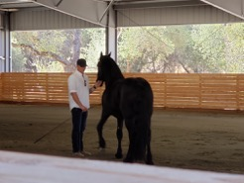
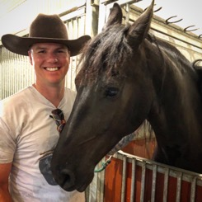
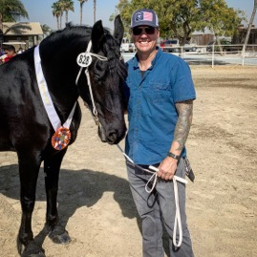
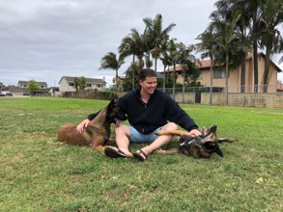
Father, Veteran, Horseman

Mathew Jenkins
  - FHANA Board of Directors Candidate
  - 559-760-1367 mathewajenkins@gmail.com
Why am I running for a position on the board of directors? The answer is simple. I believe in Magic. The magic that these incredible horses bring into the world and the lives of everyone they encounter. I want to see my children have an organization that continues to protect and promote the horses they love so dearly.  I have spent most of my life in a barn or on the back of a horse. At Windhorse Mountain Friesians, I spend my days working with and taking care of our amazing horses. The passion and experience I have for Friesians coupled with my career in business, and previous positions I have held on other boards provides me with a unique skill set; A fresh perspective that will allow me to represent Friesians, their owners and breeders in an effective fair and ethical manner. Most importantly owning a Friesian is fun, I am confident I can bring a sense of excitement and enthusiasm to the FHANA Board.  Professional Experience  Over 20 years of Executive Sales and Marketing expertise  - Former President MHS Football Booster Club  - Successful Small Business Owner |  | 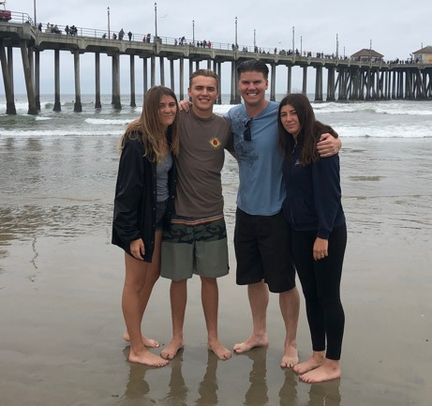  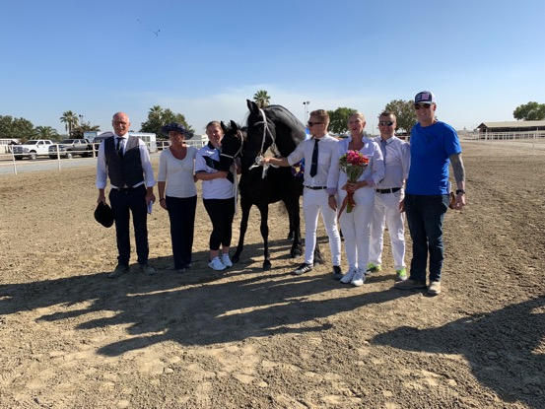

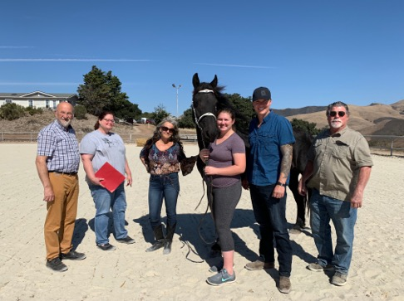 |  | FHANA Involvement  Mare Show West Committee Member  - Central California Kuering Committee Member  - Participation at FHANA 2019 AGM  - Attendance at FHANA 35th  - Attendance at KFPS Stallion Show  - Completion of KFPS Level 1 judges course
Three Initiatives  - Giving Back to Veterans  - Engaging Young People  - Increasing Hands-On Education  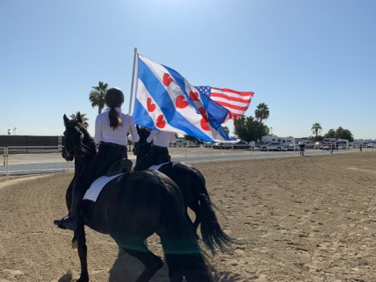 |  | 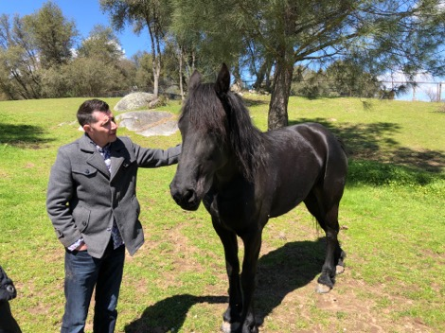

Hobbies
- Fishing
- Movie Prop Fabrication
- Aviation
- Spending time with my children
- Training my Belgian Malinois
Equine Goals  - To build and drive a Chariot  - Take Dressage Lessons  - Introduce others to Friesians  - Continue to help Veterans through Equine Therapy |  | 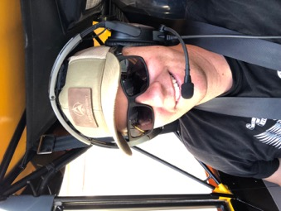

2020 Board of Directors Election Questions:
- Please describe your credentials which would help you to be an effective FHANA board member. Explain how these credentials have aided your past participation in FHANA and its related organizations (committees and chapters) and events.

Being a board member isn’t just about making decisions, it is being able to take the information provided, with consideration to the people, region and most importantly the horses to make an informed decision within the purvey of the FHANA Bylaws.

My credentials include over 20 years of sales, marketing and executive management experience. I have built sales teams and managed them across the United States and Canada. After traveling to most of these regions I have a good grasp on what makes each area unique and special.

I enjoy meeting and learning from others, this has been helpful to me throughout my life and especially when I have been a member of other boards. Most recently I was President of the Marina Vikings Football Booster Club with a budget of over $500,000 annually. If you think Horse owners are particular, just picture an overbearing football Mom and Dad frustrated because their Timmy isn’t getting put in as the quarterback.

I have calm demeanor and am not afraid of hard work. This year was the first year that we had a Mare Show West, as part of the committee we all came together to put on an amazing show. I am a utility player, meaning I am willing to do whatever it takes to accomplish a task. Whether it is taking out the trash or reading micro-chips there is not a task too big or small for me to handle. I look forward to the opportunity to work hard with fellow board members to accomplish some incredible goals.

- Describe three initiatives you would like to see FHANA accomplish during your term? Describe how you would recommend they be accomplished?

Veterans
FHANA has an incredible membership that has the ability to make a huge impact in helping Veterans. As a Veteran myself, I have seen the positive benefits that our horses bring. At Windhorse we have partnered with the Battle Buddy Foundation to introduce Combat Veterans to Friesians. How fitting for a horse that fought in some of the world’s most historic battles, to be used to assist our current warriors struggling with post-traumatic stress. I would like to form a Veteran Committee and explore how FHANA can partner with Veteran organizations and Friesian owners to provide Friesian experiences for our men and women that have served our countries.

Youth
The future of FHANA is our young people. The KFPS has started a youth program that is having great success in the Netherlands. I would like to see FHANA replicate this program here in North America. A youth committee would be a great start to explore the next steps in reaching out to young Friesian lovers.

Education
FHANA currently does a great job of posting educational material online, but I would like to see more hands-on clinic type education opportunities be offered in North America. After attending the Judges Level 1 Course out on by the KFPS I was blown away at the amount of knowledge I gained. I would like to see a Level 2 Course in 2020 in NA as well as additional Level 1 Courses. It would be great to see courses available on breeding, starting young horses, driving and what the membership would attend and find beneficial. The key to this is engagement, as a board member I would help engage the members and find out what type of training they would want. Then FHANA can work with local chapters to host and promote the event, so it is well attended.

- What current membership benefits do you feel need to be improved, and what could be added to make FHANA more attractive to past members, existing members, or new members?

FHANA has phenomenal resources for the membership. I think the potential disconnect that exists is engagement. Members want to feel like they are part of the process. It is the role of a board member to connect with the membership and ensure that their voices are heard. Whether one owns a single horse or one hundred, it is important to that member that the FHANA board understands and cares about their needs.
Every member is different and has their own goals and objective with their horse. As far as past members are concerned, they need to be contacted via telephone and asked what we can do to get them to join FHANA again.

With existing members; I would first recommend a survey be sent out to the membership and I would ask them the above questions. I would then engage the club presidents and find out what they need.

When it comes to attracting new members, that is the role of everyone who owns a Friesian, we need to constantly be ambassadors of the breed and be recruiting new people to join our incredible world.

- In your opinion, what are the most important issues facing FHANA going forward, and how would you address these issues as a Board member?

I feel that there are two key issues facing FHANA in the near future. The first is a decline in membership due to other registries, young people not getting involved or members that are unhappy with FHANA. The best way to address this matter is engagement. This is a recurring theme in my answers, but I feel it is critical that the FHANA Board engage the membership and be available to them. My three initiatives will help address the above issue as well as they create excitement for FHANA.

The second potential issue we face, is that to the general horse public Friesians are classified in a boutique nature and unattainable by mere mortals. FHANA and its members need to continue to educate other horse owners about the versatility and opportunity within the breed. FHANA needs to continue to participate in as many equestrian type events and explore new opportunities as well. As a board member I would suggest we have each regional chapter provide a list of events/shows that they would like to attend. We are the stewards of the breed, so the burden falls upon us all to share the magic and wonder of these black beauties.

