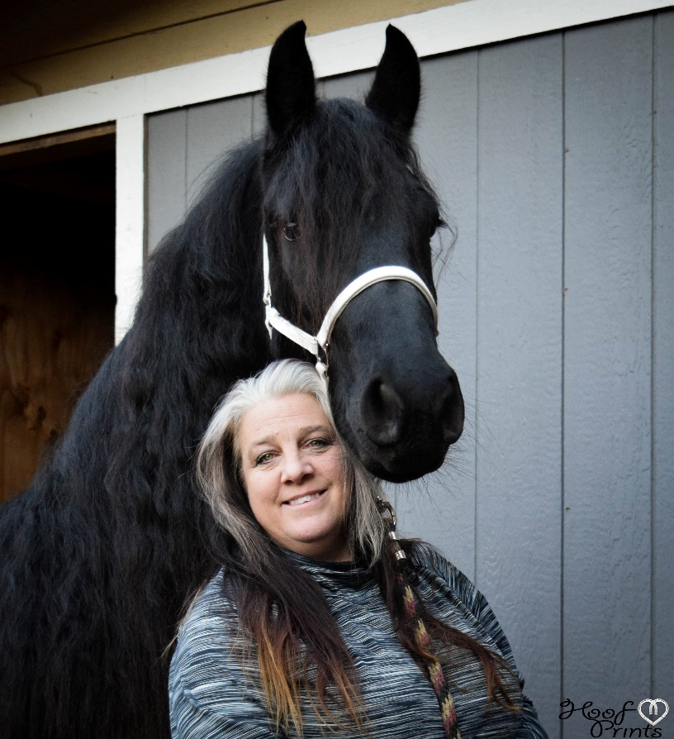

My Horse business is Gala Friesians that I’ve run since 2007. I live in Washington state and work at YMCA Camp Seymour. I started out as a member of North West Friesian Horse Club and am now a member of the Pacific Friesian Horse Club. Accomplishments in the Friesian world include; assisting in running the auction at the AGM for FHANA in 2014, serving as Treasurer for NWFHC in 2015-2016, helping run auctions for PFHC 2017-2018, and serving on the FHANA Membership Committee and the FHANA Membership Council this last year. Serving on the FHANA Board for the year 2019 as The Treasurer and chairing the Financial Committee as well as being the board liaison of the Membership Committee and being on the AGM Committee.

My favorite success has been these last two years as I have helped launch and run a horse breed exhibit for the State of Washington at the Puyallup Fairgrounds. We had our FHANA booth and horses and got to interact with an average of 10,000 people per day for over 19 days. Being able to represent the Friesian Breed and registry for the State of Washington has been an amazing experience.

I’m a small time breeder and have only had nine foals over the years. I don’t have a lot of money and it often takes me months to save up to attend a Keuring. I spend years picking out my pairings of stallions and my mares. I research and I’m extremely thankful for the information that FHANA and the KFPS provides. The ability to asses not only the stallions’ values, but to get offspring reports is the key to protecting and staying true to the breed.

I feel it’s extremely important to be protective of this breed while maintaining healthy horses. The recent addition of testing mares is a huge asset for making well educated decisions. As we look into the future, eliminating high-inbreeding as well as reducing genetic issues while producing sound and beautiful Friesians should be a main focus for all breeders.

**Amy Rogala-Hobbs**

Food Service Director

**Camp Seymour and Camp Lake Helena**

**YMCA of Pierce and Kitsap Counties**

**BOARD EXPERIENCE**

Pierce County Park Board, Peninsula Park Board, Key Peninsula Park Board, Park Commission, Peninsula Athletic Association Board, North West Friesian Horse Club, The AGM Auction and Fundraising Board, FHANA Membership Committee, FHANA Membership Council, FHANA Finance Committee, FHANA AGM, FHANA Board of Directors.

*Change is inevitable; and with change comes opportunity.*

**• Please describe your credentials which would help you to be an effective FHANA board member. Explain how these credentials have aided your past participation in FHANA and its related organizations (committees and chapters) and events.**

I’ve spent the last 30 years in kitchen management. At times, I have had 100 plus employees and multiple departments having to work in a cooperative environment. I now have 12 years of Non-Profit Management. Learning how to provide for many with limited funds and providing inclusive, educational, and honest work is an amazing experience. One of my strongest suits is underspending and working with a budget. My other side is management style. I believe in listening and fixing volatile situations. You can’t pick sides but you can seek compromise. We win or lose as a team.

Too often the loudest person in the room can decide things. This can be intimidating and overwhelming for people. I believe in listening and trying to understand where negative emotions come from. It’s important to listen to our leaders as well as our smallest members. We need to find ways to keep and grow our membership.

Lastly, over the last couple of years, I have made hundreds of letters and phone calls for donations. In the Friesian industry, I’ve raised over $8,000 for auctions to support my local chapters. I believe we can’t always depend on members to pay for growth and development of our clubs. Finding ways to help cover member costs and make events affordable is every chapter and board’s responsibility.

**• Describe three initiatives you would like to see FHANA accomplish during your term? Describe how you would recommend they be accomplished?**

One area I would love to see FHANA grow is developing a big brother/sister or buddy program. I know when I first started I was confused, overwhelmed, and totally lost learning about our Registry. When attending the one or two yearly events and meetings, I didn’t want to risk looking dumb or asking annoying questions. Lucky for me, someone took me under their wing and answered questions for me. In fact, to this day I still ask them stuff and I’m so thankful they still answer and explain things to me. This program would allow people to not just have the sellers handing out information. This program should also help new people feel included and welcomed. It will also help educate new members about things FHANA offers and how to best support each other.

I would also like to see a Welcoming Committee in FHANA. I have seen way too many new members disappear because they didn’t connect with people in the industry. Some of this could be due to location, time, or money. However, if we greeted them, helped introduce them to owners and chapters in their area, helped them know when events are happening, and even encouraged them to take surveys and vote, then perhaps we can retain more members. This would also provide an opportunity to track when new members don’t renew and ask for an exit survey or statement. This could help us understand what we could do to stay stronger.

Finally, after talking to many members I believe sharing any and all information on genetic issues, breeding reports including frozen semen, and current information on health issues is a major part for the Friesians success. We don’t want to put out partial theories or unproven facts because that can make people panic, or do damage to bloodlines. We do need to know the most recent information and discourage breeding poor genetic carriers and bloodlines.

**• What current membership benefits do you feel need to be improved, and what could be added to make FHANA more attractive to past members, existing members, or new members?**

I believe welcoming new Friesian enthusiast and owners will help make people feel involved and comfortable. Providing stepping stones for new people and answering questions will allow people to learn at their own pace. We shouldn’t just send a link to a webinar and not provide interaction. FHANA provides some absolutely amazing information and it’s important that we help people understand what they are learning. Everything from stamlines, the stallion tree, to inspections can take some people years to understand. Sharing our passion and helping people digest information will only make our membership stronger.

I also believe tracking new members and helping them fit in will help with membership retention. If people feel welcomed and learn how to get involved, then they are more likely to stay. Often I hear “I didn’t want to bother people” or “no one really spoke with me” as the reason why people stop coming to events. Some people really want to get involved and just don’t want to look silly or know where to start. It’s also important to ask people why they don’t come back. Not every member will stay but if we can keep more, then it will help grow our registry and keep fees down.

A recent study in YMCA Club membership states: a main reason Members will leave is because the failure to connect. Member related reasons point to a failure.  They relate to what didn't happen. That is a failure to connect, engage, personalize, energize, achieve goals, and feel comfortable.

**• In your opinion, what are the most important issues facing FHANA going forward, and how would you address these issues as a board member.**

Being welcoming, inclusive, and trying to proactively encourage diversity is what’s perceived as core business. We need our Registry to help promote chapters that are safe, fair, and inclusive with a culture that promotes growth and development, operating in a way to grow our Friesian Community. There are many benefits to growing our membership

• Increasing membership – which can add to the financial stability of an association and Registry.

• More members– which can add new levels of competition, interaction, and things to do.

• More volunteers – from a wider network of community family and friends, adding to the richness and diversity of the Registry.

• More expertise in breeding, training, and administration.

• Greater social benefits of forming and maintaining new relationships and bonds. • Closer engagement with the wider community and businesses (and potential sponsors). • Good, positive stories to share with the local and online media.

• A fresher, more vibrant organization – with new people come new ideas, innovation, flexibility and creativity.

Our recent board members have done a great job and I would be honored to work with them. I would love to contribute by focusing on ways to create an atmosphere that is inclusive and focused on membership retention. Creating a place that welcomes and connects with current and new members will be one of the best ways to keep FHANA affordable, our industry growing, and sharing our passion of the Friesian horse.